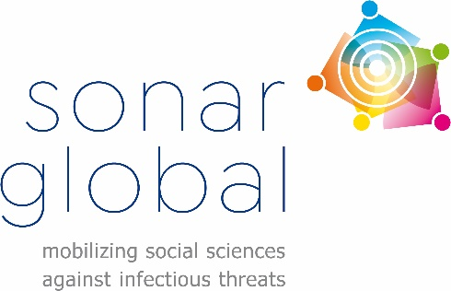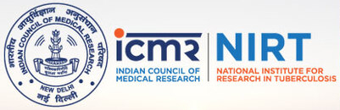

Symposium report
Leveraging social sciences in the global fight against Tuberculosis:
Sharing experiences from across the globe
19th of April 2021

Tuberculosis (TB) is a main cause of death in low and middle-income countries and very few forums for social scientists engaged in tuberculosis research have been identified. For that, Sonar-Global has collaborated with ICMR-NIRT institute in Chennai, India in a symposium to unite researchers aiming to understand the social dimensions of TB. The symposium was held on the 19th of April to facilitate exchange on social science research, address the social & economic aspects of TB, and foster potential collaborations among social scientists who work on TB in India and abroad.

The symposium encompassed an introduction session, two main sessions and a closing session:

Introduction:
In the introduction session Dr. Karikalan, scientist at the ICMR-NIRT institute in Chennai India, provided an historical perspective on TB and stressed the need to involve the social sciences in efforts to address the disease. This crucial contribution of the social sciences was endorsed by Dr. Padmaprivadarsini, director of the ICMR-NIRT chapter in Chennai, who underscored the need for Indian as well as international collaborations to make a sustainable impact. Dr. Tamara Giles-Vernick added that Sonar-Global looks forward to collaborating with NIRT now and in the future to facilitate these collaborations and effectively address the social determinants and consequences of TB.

Session 1:
The first session of the symposium provided impressions of the social dimensions of TB from around the world – from Asia (Uzbekistan, India), to South America (Colombia), to Africa (south-Africa). Social scientist Dr. Shona Horter, kick started the first session with a presentation reflecting upon the experiences of people affected by TB in Uzbekistan. She underlined the importance of holistic, person-centered approaches to TB care to align with people’s needs, to get them engaged in TB care and to address the social dimensions.

The second speaker, Prof. Jens Seeberg from the department of anthropology at Aarhus University, Denmark, shared some key social science concepts, dived into examples of past social science contributions to TB control in India and presented some of the most pressing social science research topics at present, including systemic triggers of drug resistance, mobile populations, multispecies TB, and the importance of One Health, living with (DR)TB and syndemic impacts.

Via a video presentation, Dr. Hana Henao-Vanegas from the Universidad de Antioquia, Colombia, addressed careful TB control in Colombia taking into account not only technical and epidemiological measures but also emotional, spiritual, governance and community issues. Providing guidance to policy makers and healthcare workers to improve patient communication, performance of isolation practice and infection control strategies to ensure reciprocal care and overcome structural issues in TB control.

To round off the first session, an excerpt from the ethnographic film “TB in town 2” made by visual and medical anthropologist Dr. Lianne Cremer from VU University, Amsterdam the Netherlands, was shown. These 15 minutes of footage highlighted patients’ resilience and adherence to TB treatment in the township Khayelitsha in Cape Town South Africa.

Session 2:
The second session included TB-related social science insights and experiences from India, while putting these in international context. Dr. Karthikeyan from the Karnataka Health Promotion Trust in Bengaluru India underscored how engaging the community is one of the crucial foundations of eliminating TB. Key considerations to ensure optimal engagement include: to make use of existing community structures; to work with vulnerable communities; to focus on gender; to respond holistically, and to position TB engagement within a broader health agenda to promote greater ownership.

The next speaker, Dr. Karuna Sagili (The Union, New Delhi India), reflected upon the social issues and outcomes of TB as well as the management of multi-drug resistant TB via social prevention strategies. She highlights how stigma and discrimination are an important social aspect and outcome of TB: mostly caused by fear, myths and lack of correct knowledge and awareness they lead to reduced marriage prospects, social isolation, branding and school drop-out. This stigma and discrimination, along other areas of social development (e.g. living conditions, nutrition, financial situation, infrastructure) should be taken into account when developing and implementing prevention strategies to improve the management of (multi-drug resistant) TB.

The economic dimensions of (MDR) TB in India were discussed by Dr. Muniyandi from the department of health economics at the ICMR-NIRT, Chennai India. He stressed that especially (multi) drug resistant TB, which has a higher prevalence in the poorer rural and marginalized populations, comes at higher socio-economic costs. To relieve this burden of MDR TB in India (second highest total number of cases globally) patient and provider barriers to health care need to be removed for instance by improving patient friendly diagnostic procedures, reach out to identify missing cases improve access to care and increase knowledge.

In the final presentation, medical doctor Dr. Aparna Iver from Médicins Sans Frontières outlined the socio-economic challenges that drug-resistant TB patients face (e.g. housing, stigma, nutrition, work absence, higher expenses, migration), which have only increased during the COVID-19 pandemic. In order to overcome these socio-economic challenges, holistic care should be provided, which should also encompass palliative/end-of-life care services.

Closing:
To finalize the symposium Dr. Karikalan and Dr. Tamara Giles-Vernick emphasized the need to link up the expertise on the social dimensions of TB via building a sustainable network of social science researchers and interventionists to overcome working in silos. Regular meetings, conference symposia and a taskforce were all suggested to take this effort forward.

